**CODECHEF BIT CHAPTER**

**Smart-A-Thon**

**Concept and Design Document**

**By:**

**Surya Narayanan CS**

**Monish SR**

**Sutharshana**

**Yazhini R**

**Department: ECE**

**Theme: Health Care**

**Title: Gesture Recognition and SOS**

**7th SENSE**

**(GESTURE RECOGNITION and SOS)**

***Problem Statement:***

In our society we have people with disabilities. About 360 million people in the world are deaf and dumb. Communications between deaf-mute and a normal person have always been a challenging task especially in the public place. Sign language helps deaf and dumb people to communicate with normal person. But not all people understand sign language.

***Solution:***

Our system focuses on the problem of gesture recognition in real time that sign language used by the community of deaf people and dumb people. It uses Color Segmentation, Skin Detection, Image Segmentation, Image Filtering and Template matching techniques like correlation. Reusability is one of the important factors that decides the ultimate fate of the environmental impacts created by a product in its lifetime.

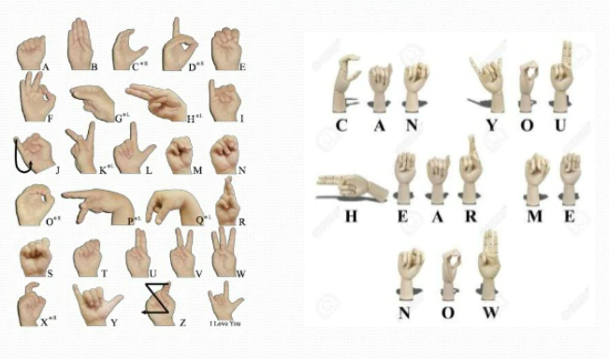

***Objective:***

Our project presents a man machine interface using video camera. The system will use a single, color camera mounted above a neutral-colored desk surface next to the output device. The output of the camera will be displayed on the monitor. Shape and position information about the hand will be gathered using detection of skin.

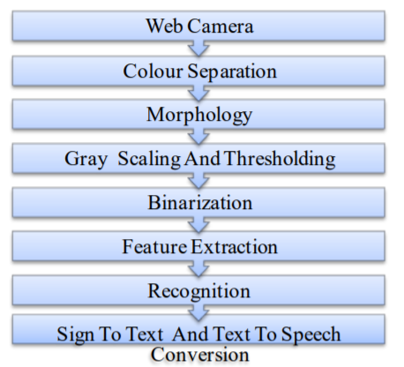

**System Design:**

In our system, image is captured through web camera. The system is implemented in offline mode and also in real time mode. Input images are applied to image pre-processing and segmentation in which, object and background is separated. Resultant image has shown some features. Then feature extraction and recognition was done by using PCA and KNN. Finally, this result is converted into text and voice.

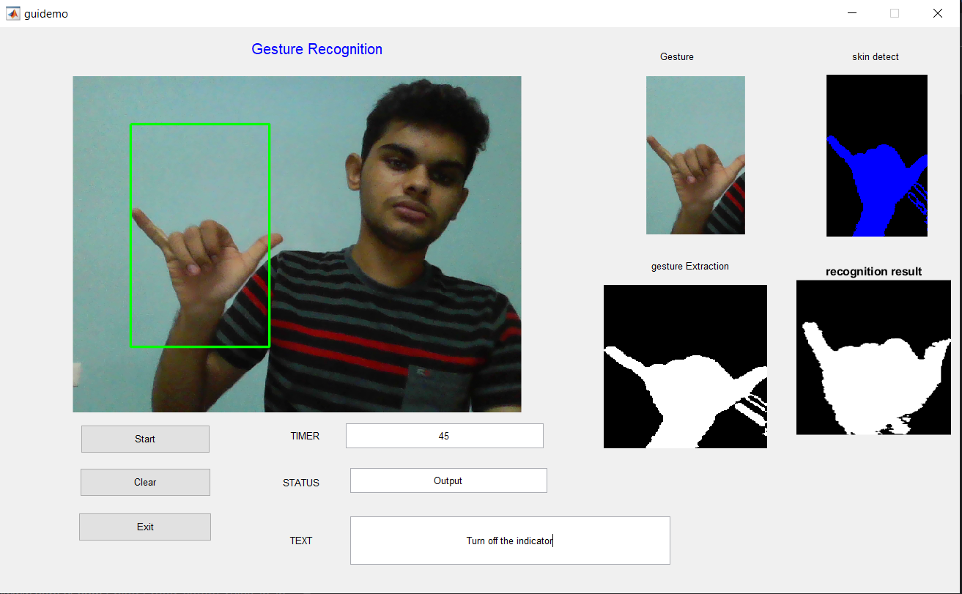

**Conclusion:**

Sign language recognition system for deaf and dumb people using image processing was successfully executed with high accuracy. The method gives output in text and speech format that helps to reduce the communication gap between deaf – mute and normal people. Thus, the implementation of system output is done in MATLAB environment.